ANZ IADR 61st Scientific Meeting | 26 – 28 September 2022
Hosted by The Melbourne Dental School, University of Melbourne Parkville, Australia |
Abstract submission
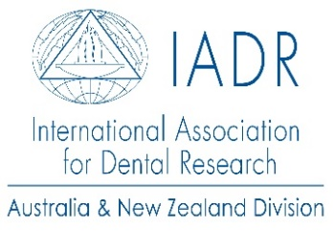
Abstract Template

Guidelines for preparing your abstract:
- 300-word limit for text of abstract body (excluding title, authors, affiliations, and references)
- Please only capitalise the first word and pronouns in your abstract title
- Make sure you include all the authors and the details of their affiliation
- Highlight the presenting author by underlining their name

Abstract titles are required to be 10 words or less.

The abstract must contain a brief statement of:

a. The objectives of the investigation,

b. Experimental methods used,

c. Essential results, including data and, where appropriate, statistics,

d. Conclusion

Abstract Deadline: 31st July 2022 11:59pm

Enter your Abstract Title:

Abstract titles are required to be 10 words or less

1 First Name, Last Name, Affiliation

2 First Name, Last Name, Affiliation

3 First Name, Last Name, Affiliation

Enter abstract here:

